**Experiment 4**

**Shashwat Tripathi**

**D15A Batch C**

**Roll No: 64**

**AIM: To create an interactive Form using form widget**

**THEORY:**

**User Interface Design:** Interactive forms require a well-designed user interface (UI) to ensure ease of use and clarity for users. Considerations include layout, labeling of fields, grouping related fields, and providing appropriate input controls (text fields, checkboxes, radio buttons, dropdown menus, etc.).

**Form Structure:** Define the structure of the form, including the types of information you want to collect from users. This could include personal details, contact information, preferences, or any other relevant data.

**Form Widgets:** Form widgets are the interactive elements used to collect data from users. Common form widgets include text fields, text areas, checkboxes, radio buttons, dropdown menus, and buttons. Each widget serves a specific purpose and is used to capture different types of input.

**Validation:** Implement validation rules to ensure that the data entered by users is correct and complete. Validation can include checking for required fields, enforcing data formats (e.g., email addresses, phone numbers), and validating input ranges or constraints.

**Error Handling:** Provide feedback to users when errors occur during form submission or validation. This helps users understand what went wrong and how to correct it. Error messages should be clear, concise, and displayed near the relevant input fields.

**Accessibility:** Ensure that the form is accessible to all users, including those with disabilities. This involves using semantic HTML, providing appropriate labels and instructions, ensuring keyboard navigation, and testing with assistive technologies.

**Submission Handling:** Define how form submissions are processed. This may involve sending data to a server-side script for processing, storing data in a database, or triggering other actions based on user input.

**User Experience (UX):** Consider the overall user experience when designing the form. Aim for simplicity, clarity, and efficiency to minimize user frustration and increase completion rates.

**Testing and Iteration:** Test the form extensively to identify any usability issues, bugs, or errors. Gather feedback from users and iterate on the design based on their input to improve the overall user experience.

**Code:**

**main.dart : Main entry point of our flutter app**

import 'package:flutter/material.dart';

import 'package:tiktok_shashwat/constants.dart';

import 'package:tiktok_shashwat/views/screens/auth/login_screen.dart';

void main() => runApp(MyApp());

class MyApp extends StatelessWidget {

const MyApp({super.key});

// This widget is the root of your application.

@override

Widget build(BuildContext context) {

return MaterialApp(

debugShowCheckedModeBanner: false,

// Application name

title: 'TikTok Clone',

theme: ThemeData.dark().copyWith(

scaffoldBackgroundColor: backgroundColor,

),

// A widget which will be started on application startup

home: LoginScreen(),

);

}

}

**login_screen.dart : This contains the login page UI and functionalities, at the moment it is not connected to the firebase.**

import 'package:flutter/material.dart';

import 'package:tiktok_shashwat/constants.dart';

import 'package:tiktok_shashwat/views/screens/auth/signup_screen.dart';

import 'package:tiktok_shashwat/views/widgets/text_input_field.dart';

class LoginScreen extends StatelessWidget {

LoginScreen({Key? key}) : super(key: key);

final TextEditingController _emailController = TextEditingController();

final TextEditingController _passwordController = TextEditingController();

@override

Widget build(BuildContext context) {

return Scaffold(

body: Container(

alignment: Alignment.center,

child: Column(

mainAxisAlignment: MainAxisAlignment.center,

children: [

Text(

'Tiktok Clone',

style: TextStyle(

fontSize: 35,

color: buttonColor,

fontWeight: FontWeight.w900,

),

),

const Text(

'Login',

style: TextStyle(

fontSize: 25,

fontWeight: FontWeight.w700,

),

),

const SizedBox(

height: 25,

),

Container(

width: MediaQuery.of(context).size.width,

margin: const EdgeInsets.symmetric(horizontal: 20),

child: TextInputField(

controller: _emailController,

labelText: 'Email',

icon: Icons.email,

),

),

const SizedBox(

height: 25,

),

Container(

width: MediaQuery.of(context).size.width,

margin: const EdgeInsets.symmetric(horizontal: 20),

child: TextInputField(

controller: _passwordController,

labelText: 'Password',

icon: Icons.lock,

isObscure: true,

),

),

const SizedBox(

height: 30,

),

Container(

width: MediaQuery.of(context).size.width - 40,

height: 50,

decoration: BoxDecoration(

color: buttonColor,

borderRadius: const BorderRadius.all(

Radius.circular(5),

),

),

child: InkWell(

// onTap: () => authController.loginUser(

// _emailController.text,

// _passwordController.text,

// ),

child: const Center(

child: Text(

'Login',

style: TextStyle(

fontSize: 20,

fontWeight: FontWeight.w700,

),

),

),

),

),

const SizedBox(

height: 15,

),

Row(

mainAxisAlignment: MainAxisAlignment.center,

children: [

const Text(

'Don\'t have an account? ',

style: TextStyle(

fontSize: 20,

),

),

InkWell(

// onTap: () => Navigator.of(context).push(

// MaterialPageRoute(

// builder: (context) => SignupScreen(),

// ),

// ),

child: Text(

'Register',

style: TextStyle(fontSize: 20, color: borderColor),

),

),

],

),

],

),

),

);

}

}

**text_input_field.dart : This contains the text input field box code which is used in our login page and will be used further in our application, hence created a separate block of code for it.**

import 'package:flutter/material.dart';

import 'package:tiktok_shashwat/constants.dart';

class TextInputField extends StatelessWidget {

final TextEditingController controller;

final String labelText;

final bool isObscure;

final IconData icon;

const TextInputField({

Key? key,

required this.controller,

required this.labelText,

this.isObscure = false,

required this.icon,

}) : super(key: key);

@override

Widget build(BuildContext context) {

return TextField(

controller: controller,

decoration: InputDecoration(

labelText: labelText,

prefixIcon: Icon(icon),

labelStyle: const TextStyle(

fontSize: 20,

),

enabledBorder: OutlineInputBorder(

borderRadius: BorderRadius.circular(5),

borderSide: const BorderSide(

color: borderColor,

)),

focusedBorder: OutlineInputBorder(

borderRadius: BorderRadius.circular(5),

borderSide: const BorderSide(

color: borderColor,

)),

),

obscureText: isObscure,

);

}

}

**OUTPUT :**

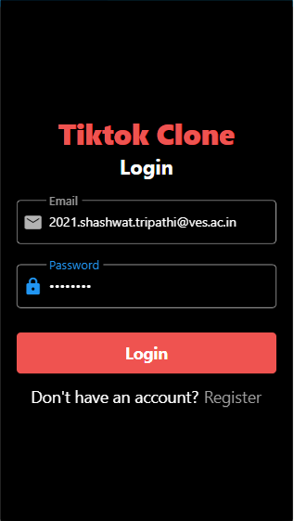 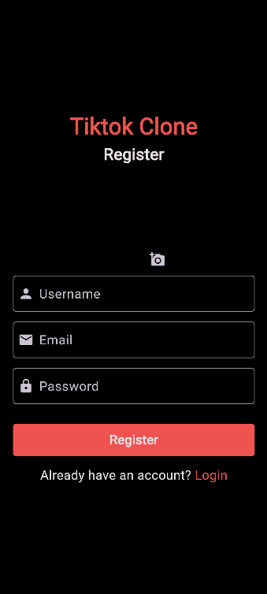

Login Screen Signup Screen

**CONCLUSION:** Thus, we have used some common widgets like Scaffold, Textinputfield, Icon, Container, Button, etc. to create our login page of the application.